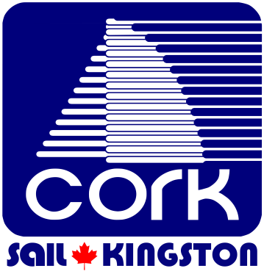

CORK Nomination Form

Date___________________________________

I _________________________________ a member in good standing of CORK/Sail Kingston

Nominate___________________________________________ to be a member of the Board

of Directors for the year ________________

Proposer __________________________________ Date_____________________________

Seconder __________________________________ Date ____________________________

Nominations to the Board of Directors are due in the office no later than three weeks prior to the AGM.
Any two members of CORK may nominate candidates for the Board.

CORK/Sail Kingston Inc.
53 Yonge Street
Kingston, ON, Canada K7M 6G4
(613) 545 1322
www.cork.org sail@cork.org

